Full Paper Template for the

Research in Engineering Education Symposium (REES) 2024
First Author Nameª (First, Last); Second Author Name^{b}, and etc ^{c.}
First Author Affiliationª, Second Author Affiliation (if different)^{b} , Subsequent Author Affiliation^{c}
Corresponding Author Email: (Leave this section as is for the double-blind review process)
Abstract (250 words)
Context
Provide a brief background of the educational phenomenon or situation being studied in this paper, including some information about what is already known. (Replace all the instructions with your text) (1-2 sentences)
Purpose or Goal
Briefly describe the motivation behind your study or change in practice (that is, what you wanted to find out). This section should include a brief discussion that identifies your research question, hypothesis or goal of the study, or the reason behind the change in practice described in this paper. (2-3 sentences)
Methods
Include a brief summary of the methodology adopted (i.e., what data or evidence was collected to support your argument, and how it was analyzed or could be used to justify the change in teaching practice). (2-3 sentences)
Outcomes
Summarize the key outcomes of your study or the change in teaching practice. (2-3 sentences)
Conclusion
Summarize the conclusions you can draw based on the evidence presented, and briefly discuss how they compare to what is currently known about the topic. If these are not available by abstract submission, summarize the likely conclusions. (2 - 3 sentences).
Keywords—Enter three to six keywords or phrases in alphabetical order, separated by semi-colons.

INTRODUCTION
T
HIS document is a template for Microsoft Word versions 6.0 or later. Please download the electronic file,
from the REES 2024 Web site at https://iucee.org/rees2024/ so you can use it to prepare your manuscript.

Guidelines For Manuscript Preparation
When you open manuscript template, select “Print Layout” from the “View” menu in the menu bar (View | Page Layout) (these instructions assume MS Word 6.0. Some versions may have alternate ways to access the same functionalities noted here). Then, type over sections of the document or cut and paste from another document and use markup styles. On the “Home” ribbon, click on the “Styles Pane” button to open the Styles as a sidebar. It will show you the “Current style” (for example, the style at this point in the document is “Text”) as well as a list of predefined styles to apply from. Highlight a section that you want to designate with a specific style, and then select the appropriate name on the style menu. The style will adjust your fonts and line spacing. Do not change the specific details of the styles such as font size and spacing. Use italics for emphasis; do not underline. Use Times New Roman font throughout the manuscript. See Table I for a summary of styles used in this template.
Non-adherence to the template will lead to rejection. This document focuses only about the formatting of the paper. For review criteria, please refer to (https://iucee.org/rees2024/ ).

Page limits
The manuscript must be limited to 9 pages including references.

Writing style

Preparing for the double-blind review process
Do not include any identifying information such as author names and affiliations in the manuscript. Make sure your figures and tables do not include any identifying information. Avoid phrasing that might reveal your identity: instead of “In our previous study … (Author, year),” use “Earlier studies found that … (Author, year),” or “Author (year) found that …”; instead of “In our institute <name>, …,” use “In a Tier-I institute in eastern Uttar Pradesh…”

General recommendations
Manuscripts must be in English. It is recommended to write in the first person singular or plural and use the active voice (“I observed that ...” or “We observed that ...” instead of “It was observed that ...”). Remember to check the spelling. If your native language is not English, please get a native English-speaking colleague or a professional technical editor to proofread your paper carefully.

Section Headings
No more than three levels of headings should be used. See Table I for formatting details and Subsection B above for an example.

Figures and Tables
Figures and tables must be centered in the column. Large figures and tables may span across both columns. It is recommended that Figures and Tables be positioned at the top of the page.

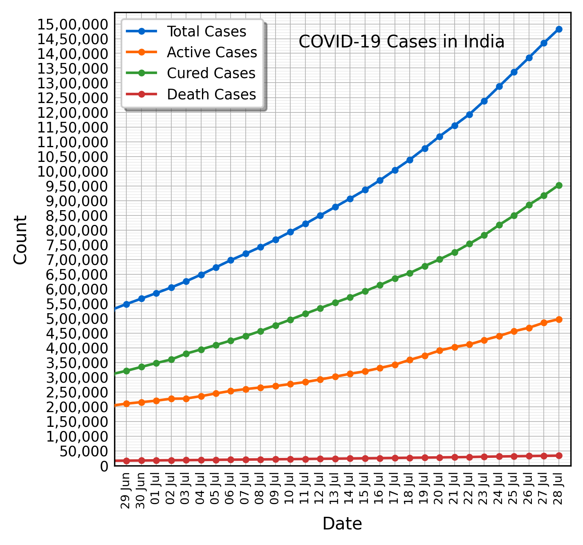
Fig. 1. COVID-19 cases in India as of July 28, 2020 (Source: https://indiacovid19.github.io). Note that “Fig.” is abbreviated. It is good practice to explain the significance of the figure in the caption.
Graphics may be full color. Graphics must not use stipple fill patterns because they may not be reproduced properly. Please use only solid fill colors, which contrast well both on screen and on a black-and-white hardcopy.
There are no specific requirements for header rows, column width, row height, use of borders, etc. Do not use colors in tables. The text in the table must be 8 pt. Figures and tables may be inserted in text boxes, as shown in these examples.
Figure and table captions should follow the guidelines in Table I. When referencing your figures and tables within your paper, use the abbreviation “Fig.” even at the beginning of a sentence. Do not abbreviate “Table.” Tables should be

numbered with Roman Numerals.

Math
If you are using Word, use either the Microsoft Equation Editor or the MathType add-on (http://www.mathtype.com) for equations in your paper (Insert | Equation or MathType Equation). “Float over text” should not be selected.
Number equations consecutively with equation numbers in parentheses flush with the right margin, as in (1). First, use the equation editor to create the equation. Then select the “Equation” markup style. Press the tab key and write the equation number in parentheses.
TABLE I
Summary of formatting styles
Section | Style | Detailsª
Title | Title | 18 pt, Bold, centered
Author names, affiliation and email id | Authors | 11 pt, Centered
Abstract | Abstract | 9 pt, Bold, the word “Abstract” is italicized
Keywords | Abstract | 9 pt, Bold, the word “Keywords” is italicized
Heading 1 | 1. Heading I | 10 pt, Centered, numbered (Roman numbers), Small caps
Heading 2 | A. Heading 2 | 10 pt, Left justified, numbered (capital alphabets), Italics
Heading 3 | 1) Heading 3 | 10 pt, Left justified, numbered (Hindu-Arabic numerals with a right parenthesis), Italics
Main text | Text | 10 pt, Both left and right justified
Figure caption | Figure caption | 8 pt, justified, below the figure, Hindu-Arabic numerals
Table caption | Table Title | 8 pt, centered, small caps, above the table, Roman numerals
Header | Header | 9 pt, italics, left justified
Footnote | Footnote Text | 8 pt, justified
Appendix, Acknowledgement, References | Unnumbered Section | 10 pt, centered, Small caps
Bibliography | Bibliography | 9 pt, justified
Vertical lines are optional in tables. Statements that serve as captions for the entire table do not need footnote letters.
ªUse Times New Roman and single line spacing throughout the manuscript.

${\left(x+a\right)}^{n}=\sum_{k=0}^{n}{\left({n \atop k}\right)x^{k}a^{n-k}}$ (1)

Refer to “(1),” not “Eq. (1)” or “equation (1),” except at the beginning of a sentence: “Equation (1) is ... .”

Page Numbers
Do not use page numbers.

Footnotes
It is recommended that footnotes be avoided (except for the unnumbered footnote with the receipt date on the first page). Instead, try to integrate the footnote information into the text. If you absolutely have to, number footnotes separately in superscripts (Insert | Footnote). Use letters for table footnotes (see Table I).

References
REES 2024 uses the American Psychological Association (APA) format for in-text and reference list citations. See a concise guide at www.mendeley.com/guides/apa-citation-guide. It is recommended that you use a citation manager like Zotero or Mendeley. Below are some examples of in-text citations; the references section should only contain the bibliography, i.e., a list of references in the APA format. In-text citations include the last name of the authors and the year of publication only, for example, “Author (year) states…” or “… (Author, year).”
- Books: Creswell (2012) explains the importance of the literature review process.
- Book chapters: Guzdial and du Boulay (2019) summarize the history of computing education research.
- Journal articles: Peer instruction is an active learning technique used successfully in college-level STEM courses (Crouch & Mazur, 2001). When citing multiple works together, separate them by semi-colons like this (Fellah & Bandi, 2018; Hamouda et al., 2019).
- Conference proceedings: Esakia and McCrickard (2016) propose an adaptive model for teaching mobile app development in computing courses.

Structuring and formatting your paper
As mentioned above, this document focuses on the structure and formatting of the paper. To structure the manuscript, please use a typical structure of a research article. To format the manuscript, you should use the styles in this document. The paper will be reviewed (and potentially) published exactly as you submit it, so be careful to follow the guidelines carefully.

Acknowledgment
Use the singular heading even if you have many acknowledgments. Leave this section as is for the double-blind review process.

References

Creswell, J. W. (2012). Educational research: Planning, conducting, and evaluating quantitative and qualitative research (4th ed). Pearson.

Crouch, C. H., & Mazur, E. (2001). Peer Instruction: Ten years of experience and results. American Journal of Physics, 69(9), 970–977.

Esakia, A., & McCrickard, D. S. (2016). An adaptable model for teaching mobile app development. 2016 IEEE Frontiers in Education Conference (FIE), 1–9.

Fellah, A., & Bandi, A. (2018). The Essence of Recursion: Reduction, Delegation, and Visualization. Journal of Computing Sciences in Colleges, 33(5), 115–123.

Guzdial, M., & du Boulay, B. (2019). The History of Computing Education Research. In S. A. Fincher & A. V. Robins (Eds.), The Cambridge Handbook of Computing Education Research (1st ed., pp. 11–39). Cambridge University Press.

Appendix
Appendixes, if needed, appear after the references.

Copyright statement (To be inserted by the authors in the camera ready copy)
The following copyright statement should be included at the end of your paper. Substitute authors’ names in final version only.
Copyright © 2024 <Replace with the names of authors>: The authors assign to the Research in Engineering Education Network (REEN) and educational non-profit institutions a non-exclusive license to use this document for personal use and in courses of instruction provided that the article is used in full and this copyright statement is reproduced. The authors also grant a non-exclusive license to REEN to publish this document in full on the World Wide Web (prime sites and mirrors), on Memory Sticks, and in printed form within the REES 2024 proceedings. Any other usage is prohibited without the express permission of the authors. –

